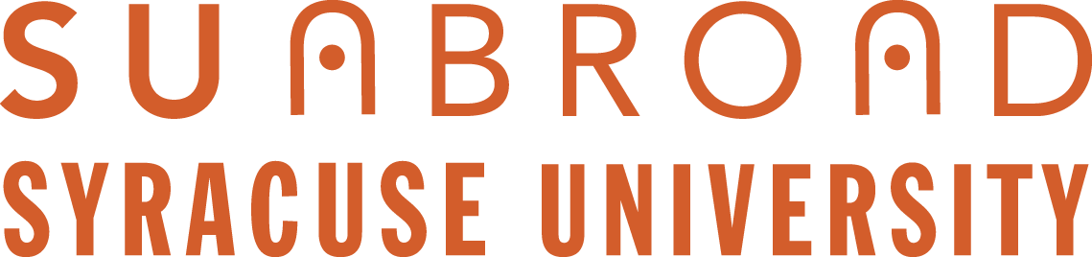

SU Abroad Summer 2018 Renewal Course Proposal Form

Please fill out the following form and email it to mkulikow@syr.edu along with a signed Terms and Conditions 2018 no later than February 10th, 2017.

SU Abroad and College Dean Joint Review of Final Submissions
Between February 15 and March 30, 2017, Associate Provost Margaret Himley, Director of Academic Programs Lou Berends, and Summer Programs Assistant Director Marie Kulikowsky will meet with individual school and college deans to review all proposals (new and returning) and finalize the lineup of summer abroad courses for 2018.

Scheduling of the program may be delayed to avoid programs competing with each other.

Faculty will be notified by June 1, 2017 with decisions.

Please note that for course proposals in Madrid, Florence, and London, the course must fit in with the summer session format.

Program name and listing:

Program location(s): city and country
(Please list all potential locations here)

Faculty leader(s) name:

Faculty leader(s) email address:

Faculty leader’s department and school/college:

What year was this program most recently offered?

Program changes/updates:

Program tentative dates:

Number of credits:

Additional comments:

