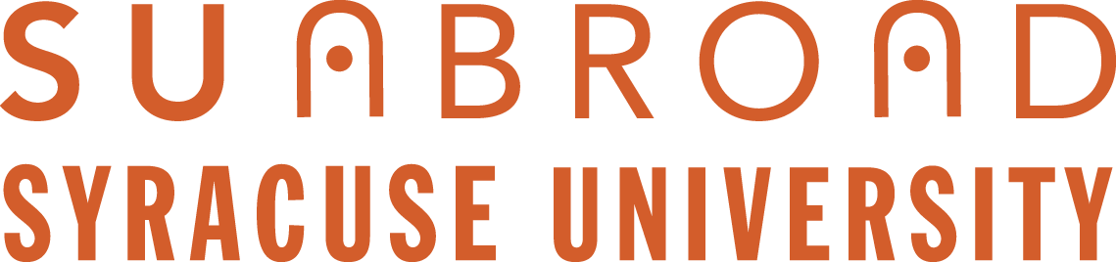

SU Abroad Summer 2018 New Course Proposal Form

- For new courses to be offered by SU faculty
- FOR TEACHING ABROAD ONLY and NOT REGULARIZED courses

SU Abroad accepts proposals from Syracuse faculty on an annual basis for summer courses taught the following year. The final proposals will be reviewed as a packet by your Dean and SU Abroad, according to already established criteria. These include:

- Priorities of the School or College
- Compelling rationale and course content
- Academic standards consistent with semester courses
- Viable audience on the SU campus and potentially beyond SU
- Program fit in context of other offerings abroad
- Support of SU Center, if offered at a Center
- Financial viability

Scheduling of the program may be delayed to avoid programs competing with each other.

Thank you for making your proposal and final syllabus submission as early as possible, and no later than the deadlines indicated below.

SUMMER 2018 NEW PROPOSAL PROCESS & TIMELINE

By February 10th: Please submit via email to mkulikow@syr.edu :

- Completed course proposal Form signed by your department chair
- Draft syllabus and itinerary
- Signed terms & conditions form

Incomplete proposals will not be considered for review.

SU Abroad and College Dean Joint Review of Final Submissions
Between February 15 and March 30, 2017 Associate Provost Margaret Himley, Director of Academic Programs Lou Berends, and Summer Programs Assistant Director Marie Kulikowsky will meet with individual school and college deans to review the final proposals based on the criteria listed above, and finalize the lineup of summer abroad courses for 2018.

Faculty will be notified by June 1, 2017 with decisions.

Please note that for course proposals in Madrid, Florence, and London, the course must fit in with the summer session format.
2018 Summer Course Proposal Form

Submitter(s) name(s):
(If course/program is team taught by faculty from different colleges, both colleges should receive proposals)

Proposed location/site(s):

Course title(s) and dept./No(s):
Is the course double numbered (e.g. 400/600) or cross-listed?
Indicate here the primary department.

Desired cross-listings:
(SU Abroad will request additional cross-listings once primary department approves)

Proposed number of credits:

Fit into SU Abroad summer offerings:
Please review existing offerings carefully at: http://suabroad.syr.edu/destinations/summer/index.html

Pre-requisites or co-requisites?
List any that apply.

Course/program description(s):
If this is a program that includes more than one course, please also provide an overall program description with the individual course descriptions. Syllabi for all courses must also accompany the proposal.

Course/program rationale: (Briefly describe how this course fits into the main campus and/or overseas campus curriculum)

Audience: Provide information on the target audience and likelihood of recruiting the necessary number of paying students. Include prospects for enrollment by both SU and non-SU students, if applicable. Provide an estimate of desired SU and non-SU enrollment, and enrollments at the graduate and undergraduate levels.

Staffing: Explain briefly the staffing plans for this course, including the use of SU and/or SU Abroad faculty and assistants. Indicate number of outside lecturers anticipated and approximate pay scales.

Program (non-tuition) costs: Please provide a description of necessary services associated with this proposed course, such as type of student housing preferred, travel/transportation needs abroad, field study/site visits/entrance fees, group meals, etc. SU Abroad will assist with cost estimates.

Comments from department chair:

Department chair signature: ______________________ Date: _____________
This signature confirms departmental support for this proposed course. It is understood that the course/program is subject to final joint approval by the appropriate College Dean and SU Abroad Associate Provost.

